Media blob from related Media Handling procedure with most recent update date

[objects: objectNumber]
[objects: title], [objects: objectProductionDate]
[objects: objectName]
[objects: briefDescription]
[objects: dimension]
[acquisition: creditLine]
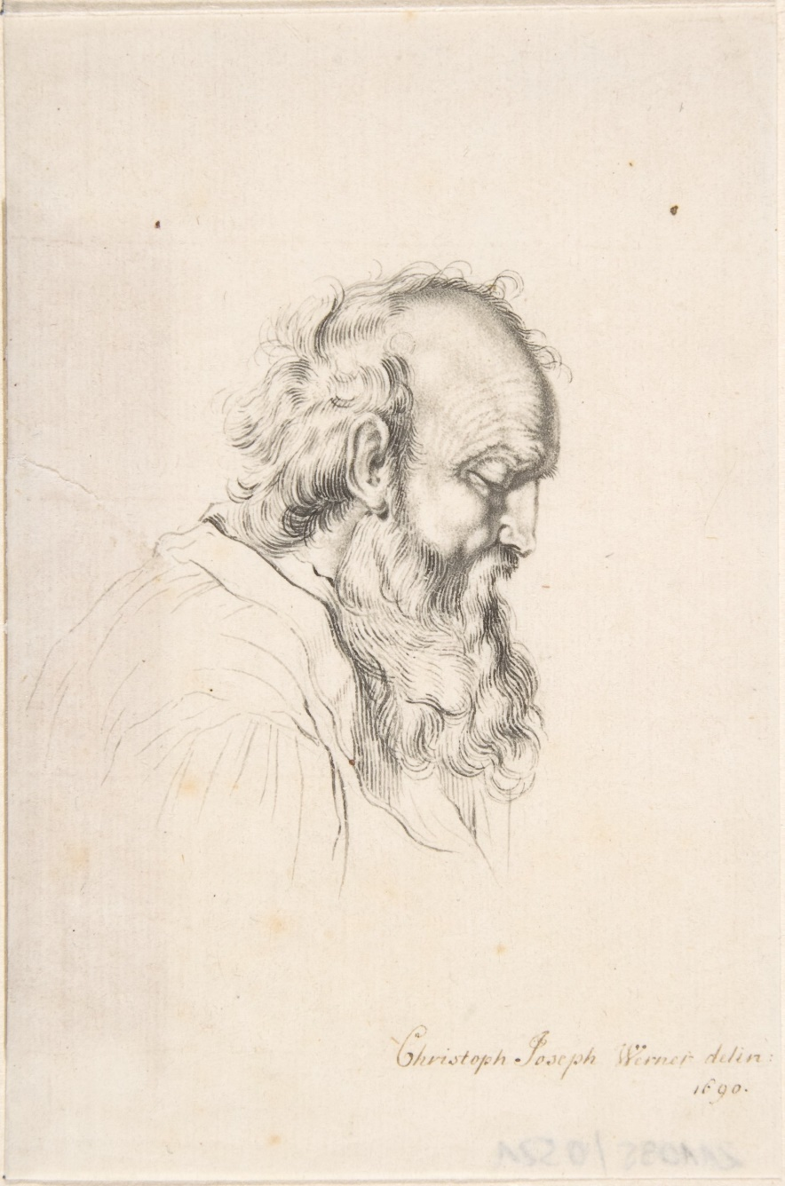

20CS.001.0001
A Man, 2015
drawing
Ut consequat semper viverra nam libero justo laoreet sit amet cursus sit amet dictum sit.
8.5 x 11
Gift of John Mellon

